

ADDIS ABABA UNIVERSITY

ADDIS ABABA INSTITUTE OF TECHNOLOGY

CENTER OF INFORMATION TECHNOLOGY AND SCIENTIFIC

COMPUTING

**Lecture one based assignment**

**Prepared by:** - Bemenet S.

**Id: -** ATR/6101/11

**Department:** - Software Engineering

**Section:** - One

**Submitted to: -** Mr. Fitsum A.

February 2020

Table of Contents

**Introduction** 3

**History of the Internet** 3

**Popular Websites** 4

**1. Amazon** 4

**2. Sweetwater** 6

**3. YouTube** 8

**4. Wikipedia** 10

**5. Pinterest** 12

**Website Categories** 13

**1. Portal** 13

**2. News** 14

**4. Business/Marketing** 15

**5. Educational** 16

**6. Entertainment** 17

**8. Blog** 18

**9. Wiki** 19

**10. Social Network** 19

**11. Content Aggregator** 20

**12. Personal** 20

**Website evaluation guidelines** 21

**Purpose** 21

**Content** 21

**Authorship/Sponsorship** 22

**Functionality** 22

**Reference:** 25

Table of Figures

Figure 1 4

Figure 2 5

Figure 3 6

Figure 4 7

Figure 5 7

Figure 6 8

Figure 7 9

Figure 8 9

Figure 9 10

Figure 10 10

Figure 11 11

Figure 12 11

Figure 13 12

Figure 14 12

Figure 15 13

Figure 16 23

Figure 17 24

# **Introduction**

This document is meant to help anyone that reads it understand what the Internet is all about. It also gives a general idea of how different websites looked like throughout the years including a snapshot of each website.

# **History of the Internet**

Before we go directly on how the Internet originated and developed throughout the years, it’s a must that one understands what the word Internet stands for or what the Internet is. The Internet simply means “Interconnected network”, it’s a global system of interconnected computer networks that share information electronically. In other words, it is a network of networks consisting of public, private, academic, commercial and governmental networks that are linked by different networking technologies both globally and locally.

The first actual prototype of the Internet was introduced in the late 1960s with the creation of the ***Advanced* *Research Projects Agency Network*** (ARPANET)*.* It was originally funded by the U.S Department of Defence. The ARPANET used a method for effectively transmitting electronic data known as “packet switching” that is now a major building blocks of the internet. The first ever message delivered by ARPANET was on October 29, 1969 and was done via a node-to-node communication between a computer located in ***University of California Los Angeles*** (UCLA) and the other one located in Stanford. Each computer was the size of a small house. The message that they tried to send through the ARPA Network was a simple note that said “LOGIN”, but the network crashed after the computer located in Stanford received only two letters thus making “LO” the first ever message sent through a computer network.

In the 1970s the technology started to develop well after scientists *Robert Khan* and *Vinton Cerf* developed Transmission ***Control Protocol and Internet Protocol, or TCP/IP***. TCP/IP is a communications model that set standards on how data should be transmitted between multiple networks.

The ARPANET adopted TCP/IP on January 1, 1983, and from there Researchers and different tech guys began to assemble the “network of networks” that became the modern Internet. The online platform then took on a more organised and recognizable form in 1990 when computer scientist *Tim Berners-Lee* invented the ***World Wide Web (WWW)***. The web is usually confused with the internet, but it simply is the most common means of accessing data online in the form of hyperlinks and websites.

# **Popular Websites**

Here are 5 popular websites from web archive:

## **1. Amazon**

Amazon is an online marketplace where you buy and sell items from a range of categories. You can buy items that range from small gimmicks and accessories to large electronic systems like refrigerators and fancy lighting/sound systems.

This website has grown and developed throughout the years and thanks to the amazing web archive website we are able to see snapshots of what it looked like in different timestamps. The images below are snapshots taken by different users at different years.

Snapshot from https://web.archive.org/web/20060522143937/<https://www.amazon.com> on May 22 2006.

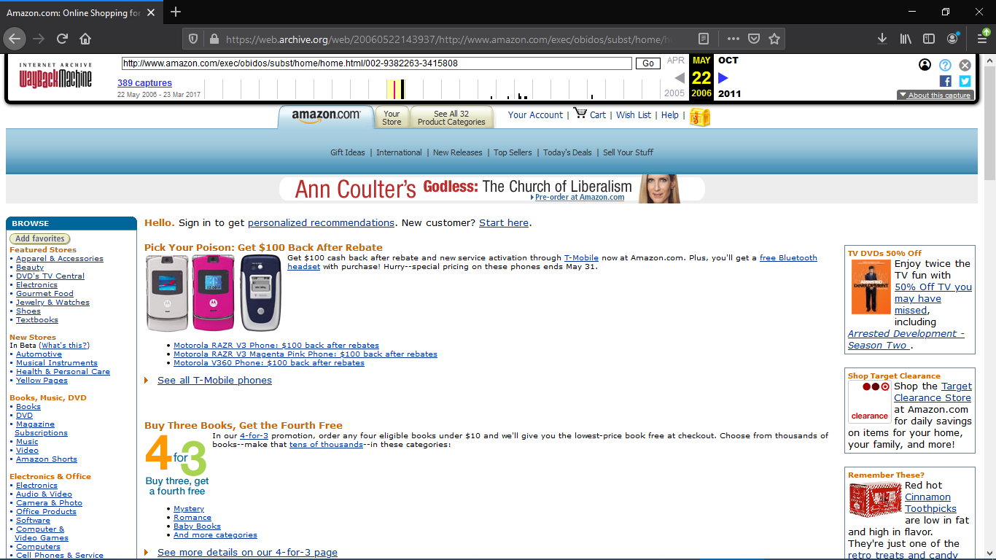

Figure 1

Snapshot from https://web.archive.org/web/20111018121102/<https://www.amazon.com> on Oct 18 2011.

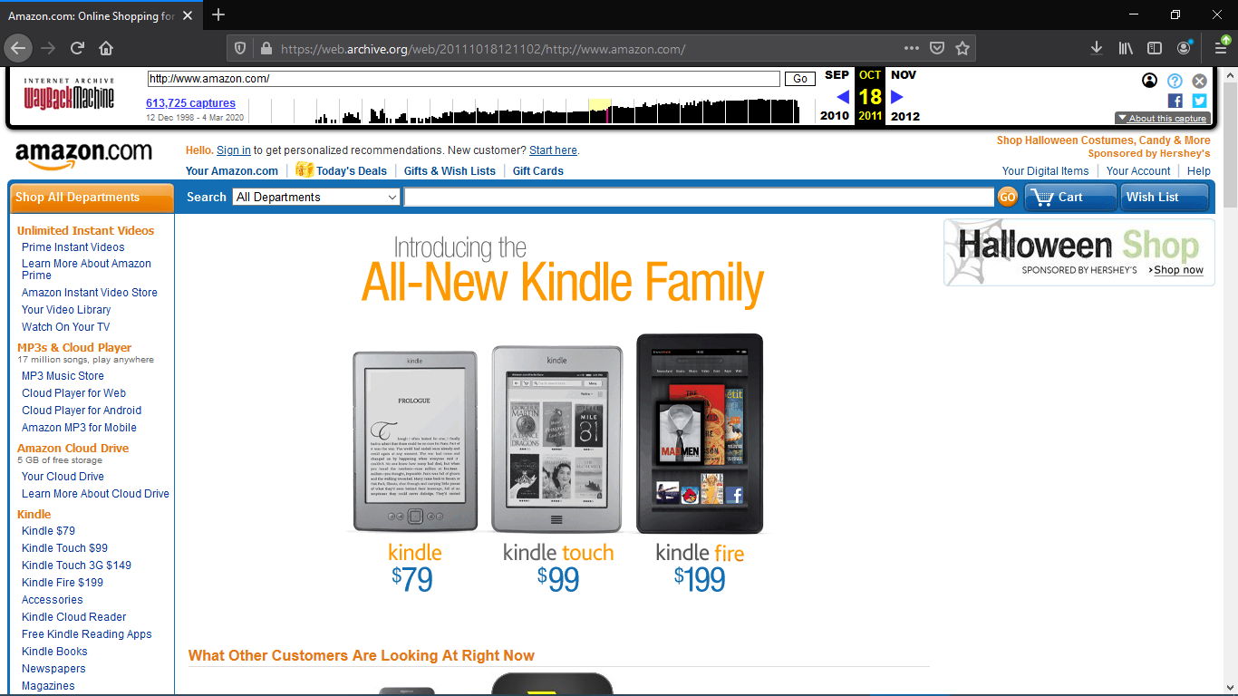

Figure 2

This is a snapshot from the current amazon.com taken from <https://web.archive.org>

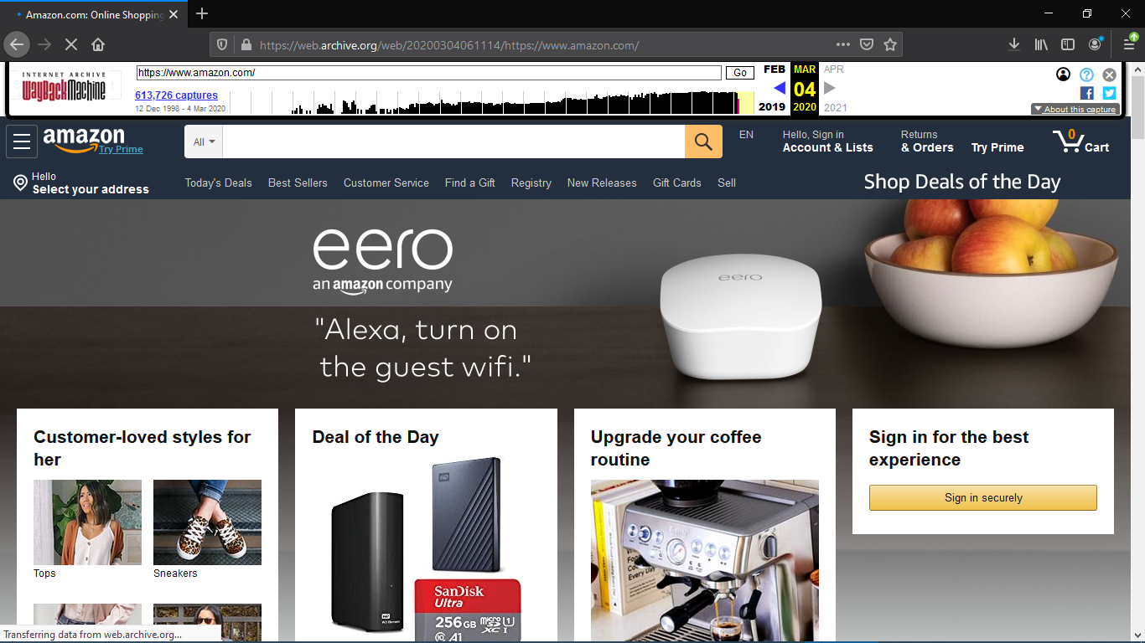

Figure 3

## **2. Sweetwater**

Sweetwater is probably one of the most versatile and well-known company when it comes to providing quality and professional sound recording equipment, ***Musical Instrument Digital Interface (MIDI)*** devices, and different recording studio gear. They have all types of microphones, studio monitors, production headphones, MIDI keyboards, guitars and a lot more so that you can get a quality recording on your ***Digital Audio Workstation (DAW)*** making it one of the most trusted sites to get the gear you want for quality production.

Just like other websites this website has grown over time and below are some images that show what this particular website looked like as the years passed.

Snapshot from https://web.archive.org/web/19990208010504/[https://www.sweetwater.com](https://www.amazon.com) on Feb 08 1999.

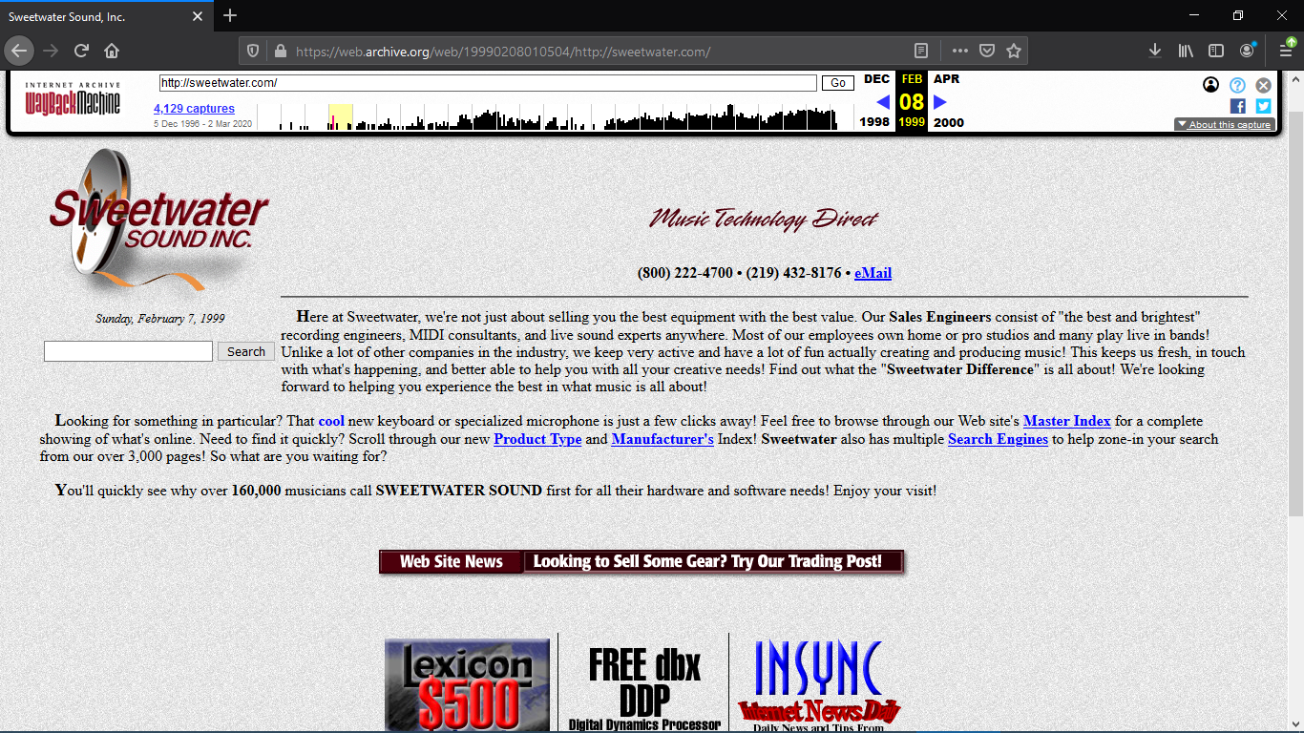

Figure 4

Snapshot from https://web.archive.org/web/20111113161632/[https://www.sweetwater.com](https://www.amazon.com) on Nov 13 2011.

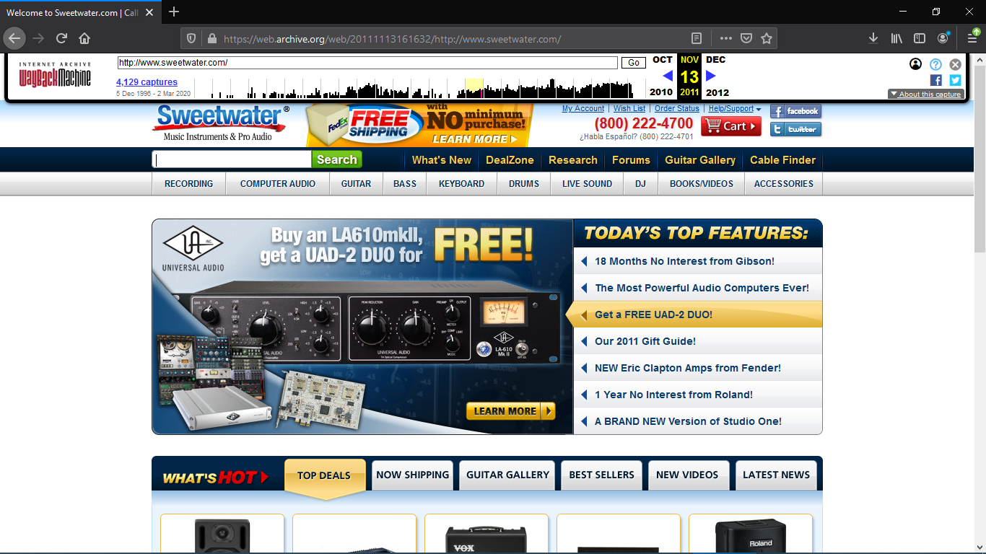

Figure 5

Snapshot from https://web.archive.org/web/20200302172451/[https://www.sweetwater.com](https://www.amazon.com) on Mar 02 2020.

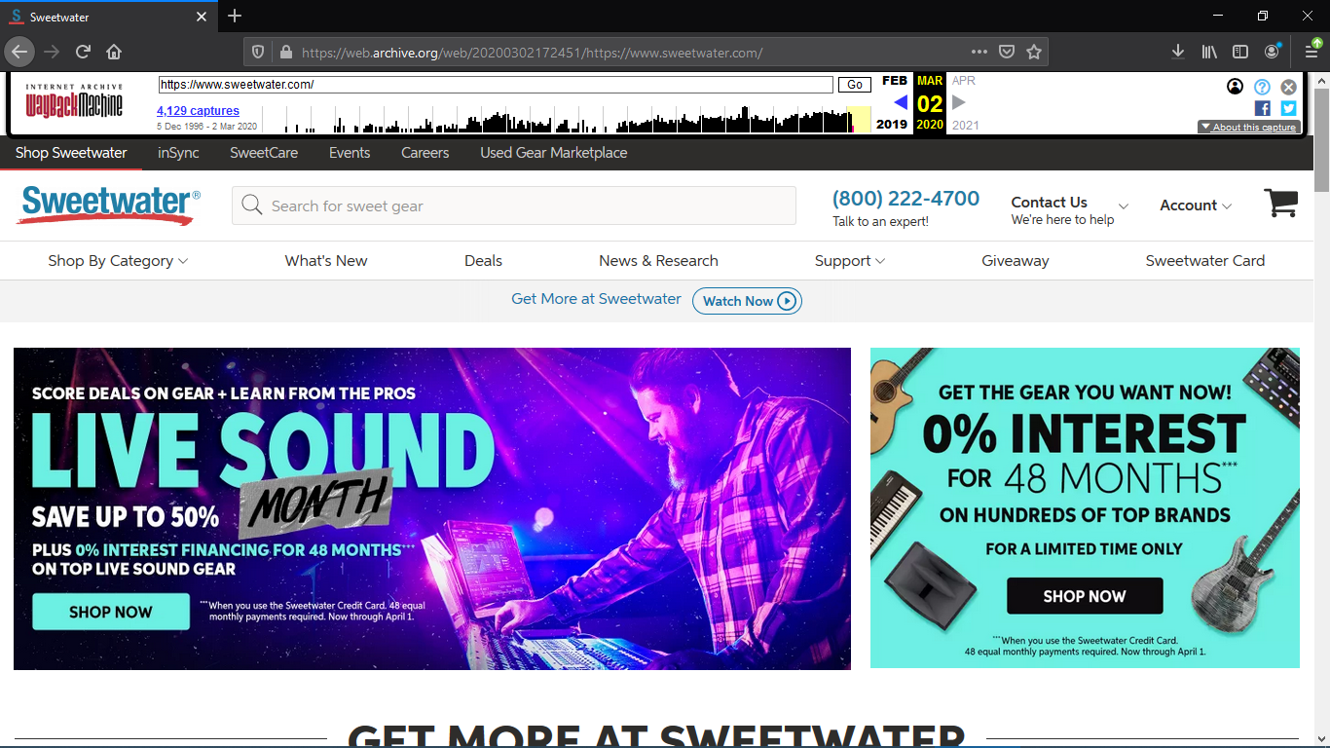

Figure 6

## **3. YouTube**

This website has been one of the most visited sites, not only because of its appealing appearance but also because it has great content within and is used time and time over by different users, institutes and/or companies for educational and entertainment purposes. This website is pretty much what everyone would go to in order to get quick answers for their questions.

Snapshot from https://web.archive.org/web/20061109210911/<https://www.youtube.com> on Nov 09 2006.

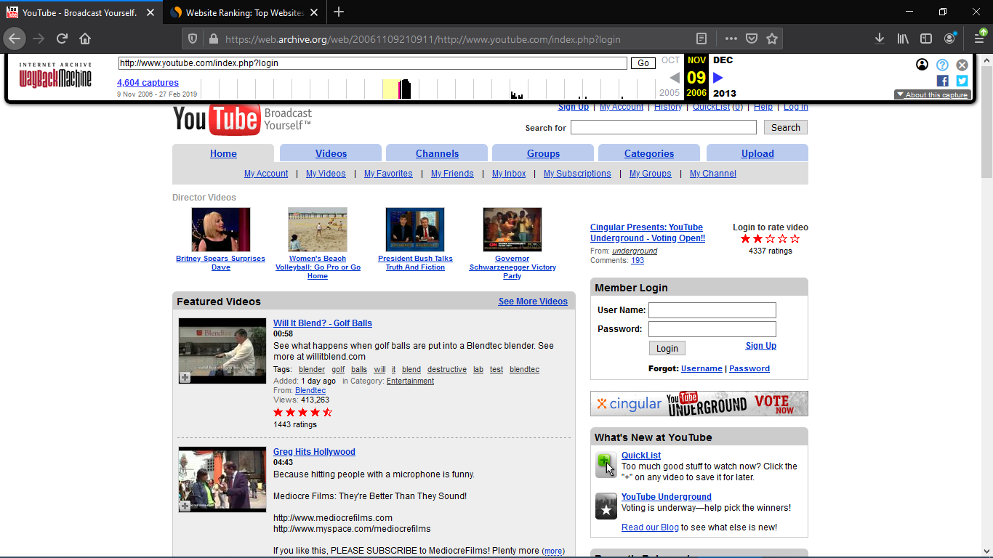

Figure 7

Snapshot from https://web.archive.org/web/20110614222230/<https://www.youtube.com> on Jun 14 2011.

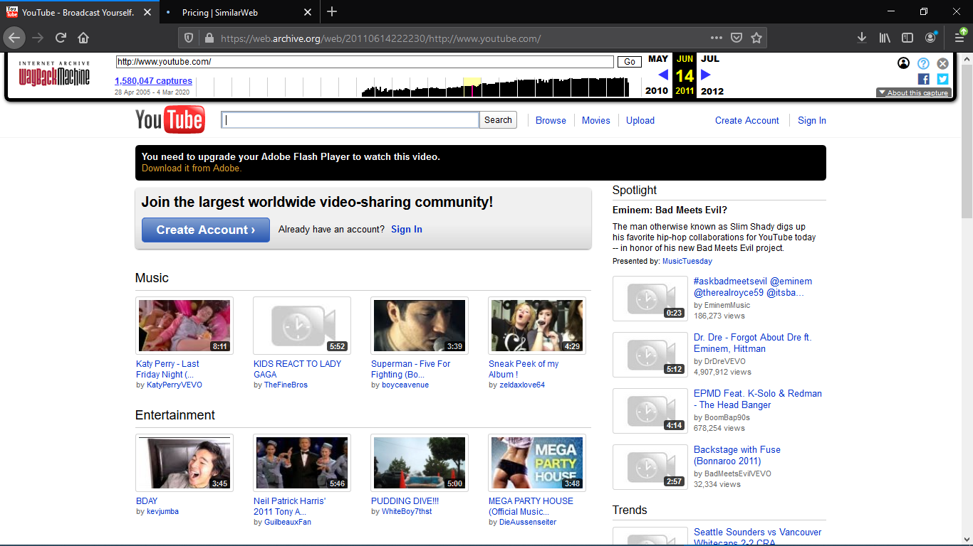

Figure 8

And this is the current YouTube site that everyone knows.

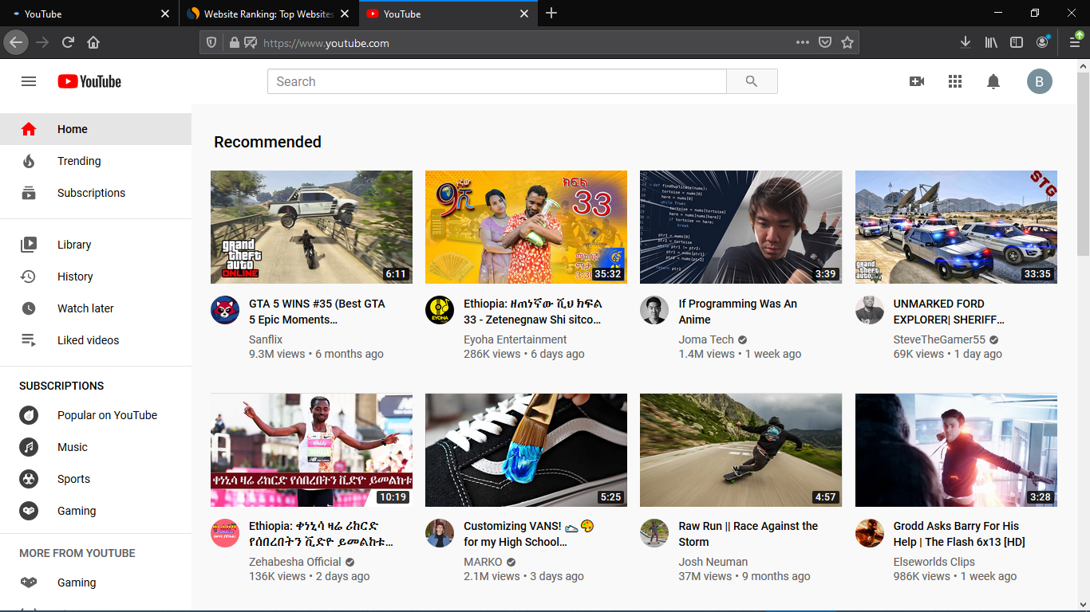

Figure 9

## **4. Wikipedia**

Wikipedia is a free-content online encyclopaedia founded in 2001, collaboratively developed over the World Wide Web in a number of languages. It is a free to edit website where individuals can edit a page collaboratively or individually in a community-based project.

Snapshot from https://web.archive.org/web/20010727112808/<https://www.wikipedia.org> on Jul 27 2001.

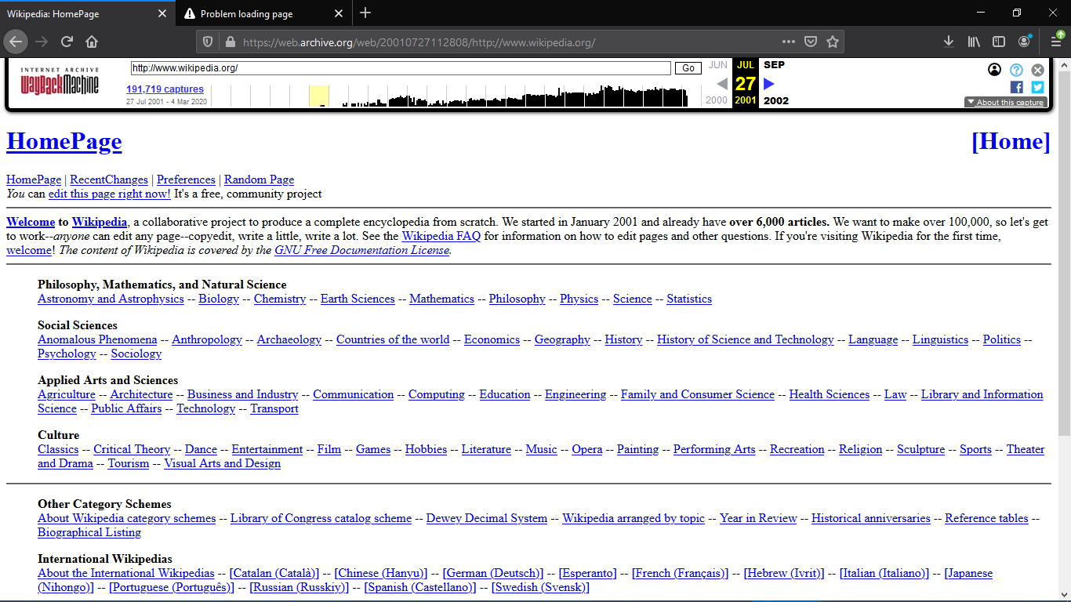

Figure 10

Snapshot from https://web.archive.org/web/20110531205846/<https://www.wikipedia.org> on May 31 2011.

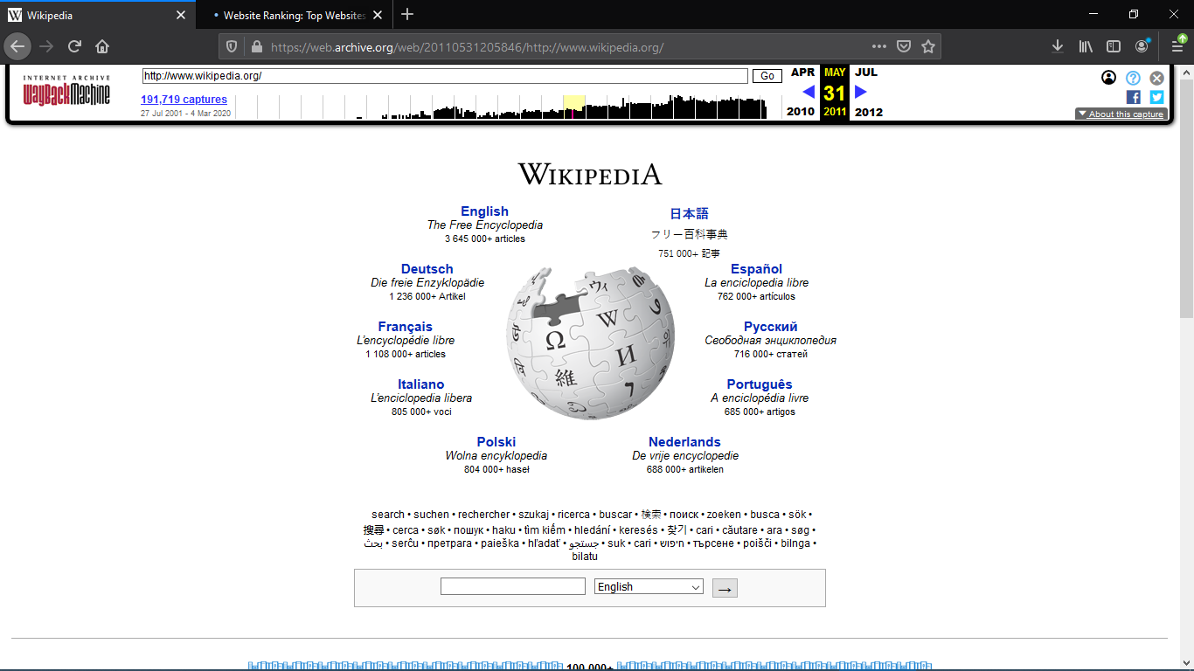

Figure 11

And currently this is what it looks like

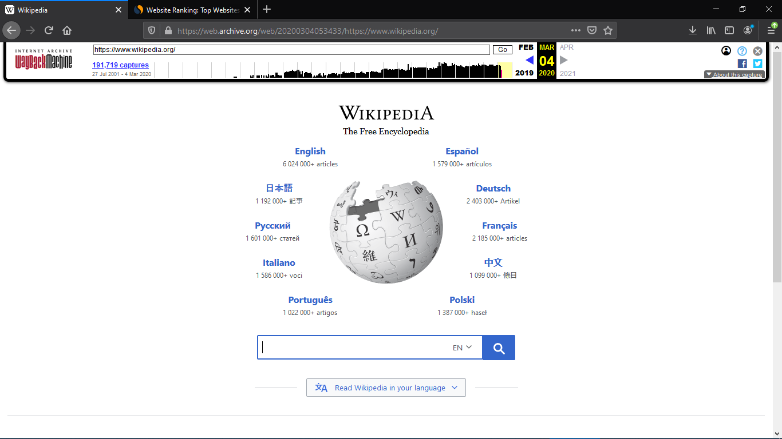

Figure 12

## **5. Pinterest**

Pinterest, Inc. is an American social media web and mobile application company. It operates a software system designed to enable saving and discovery of information on the World Wide Web using images and, on a smaller scale, GIFs and videos. The site was founded by Ben Silbermann, Paul Sciarra, and Evan Sharp.

Snapshot from https://web.archive.org/web/20100202235045/<http://www.pinterest.com> on Feb 02 2010.

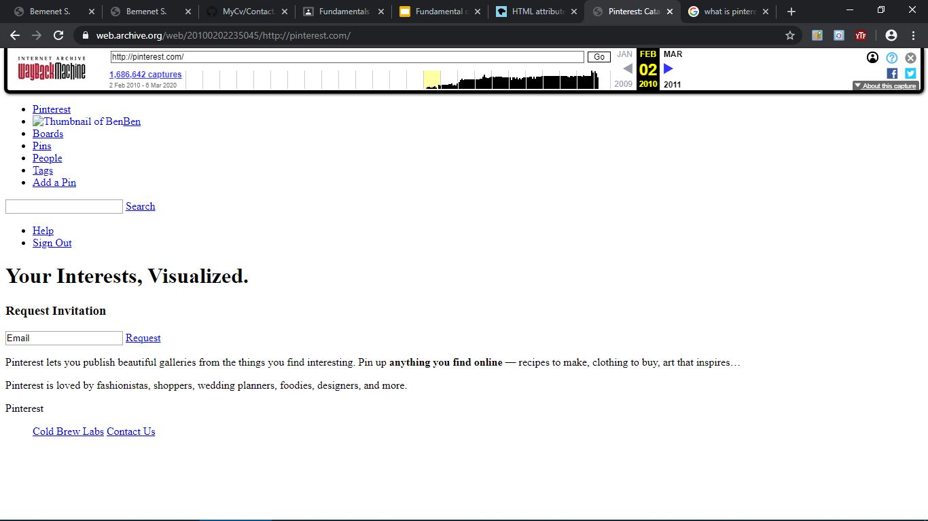

Figure 13

Snapshot from https://web.archive.org/web/20150515044443/<http://www.pinterest.com> on May 04 2015.

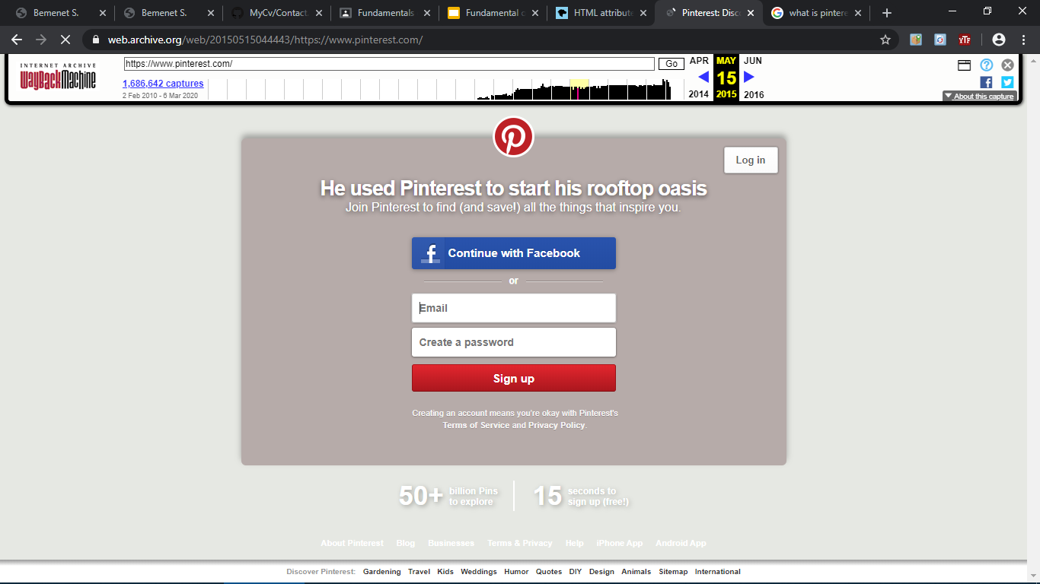

Figure 14

And this is what it currently looks like:

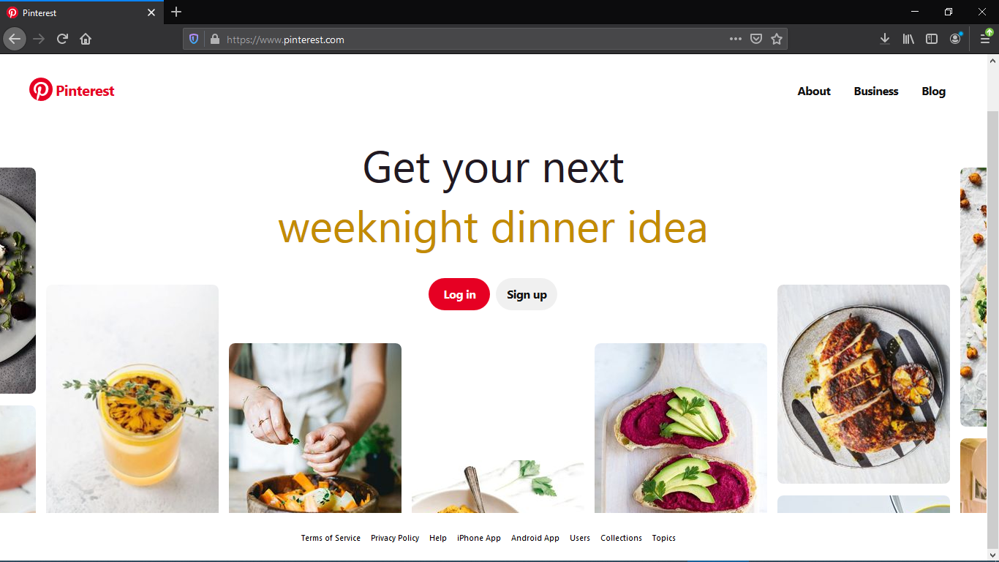

Figure 15

After viewing the above websites my overall generalization was, that all websites have different looks in different years and they have grown and added more features in to them. They have changed according to the standards of the web and are made more appealing to the eye.

# **Website Categories**

## **1. Portal**

As a web-based platform, a portal allows users to connect with one another and find content that is relevant with ease and simplicity. It combines information from different sources into a single user interface.

The portal’s functionality can provide a far-reaching impact on an organization and its processes. In fact, many companies throughout various industries are employing a [portal platform](https://www.liferay.com/resources/l/web-portal). They include the following:

* [**Santander Bank, Retail Banking Portal**](https://www.santanderbank.com/us/): <https://www.santanderbank.com/us>

This site includes several retail banking features and ability to open new accounts and manage day-to-day banking operations.

* [**CopperPoint, Insurance Portal**](https://www.copperpoint.com/)**:** <https://www.copperpoint.com>

CopperPoint is Arizona’s largest provider of workers compensation insurance and wanted to provide a better user experience for their policyholders and agents.

* [**Allianz, Wealth Management / Insurance Portal**](Allianz,%20Wealth%20Management%20/%20Insurance%20Portal)**:** <https://www.allianz.com/en>

Allianz Group, with a customer base of over 75 million, offers a site that is both dynamic and personal.

* [**UAB Medicine, Patient Portal**](http://www.uabmedicine.org/)**:** <https://www.uabmedicine.org/>

UAB's top-ranked medical professionals found a platform through which they can reach many visitors and actual patients with health concerns.

* [**Grants.gov, Federal Government Portal**](http://www.grants.gov/): <https://www.grants.gov/>

The Grants.gov program management office was established, in 2002, as a part of the President's Management Agenda. Managed by the Department of Health and Human Services, Grants.gov is an E-Government initiative operating under the governance of the Office of Management and Budget

## **2. News**

Well, if you just look a few years back, then reading newspapers considered one of the greatest hobbies one can have. But nowadays nobody has time to go out and buy a newspaper.  So, here is what the role of the internet comes into play. Online news portals allow people to read the news with ease. All you need is just have a smartphone with internet connectivity and today this is more common to have than having a pet at home.

* **Yahoo! News:** <https://news.yahoo.com/>

Yes, it’s true. You must be thinking about how Yahoo beat Google in this category? Well, the stats say it all. The website offers news related to almost every section, such as sports, finance, politics, and entertainment.

* **Google News:** <https://news.google.com>

The second on the list is “**Google News**” with over **150 million unique** visitors every month. Despite Google being the most visited website or search engine in the world, they haven’t made it to the first position.

* **CNN:** <https://edition.cnn.com>

It is one of the fastest growing online news portals on the planet. The fanbase is so huge that the website also has its own App on the “[AppStore](https://itunes.apple.com/us/app/cnn-breaking-us-world-news/id331786748?mt=8)” and “[Play store](https://play.google.com/store/apps/details?id=com.cnn.mobile.android.phone&hl=en_IN)“. They even have a TV news channel which is viewed by millions of viewers across the globe.

* **New York Times:** <https://www.nytimes.com>

It’s an American based newspaper from New York city. Due to its high popularity, the website receives the love of nearly 70 million unique visitors every month.

* **Fox News:** <https://www.foxnews.com>

It is based on United States TV news channel owned by “Fox Entertainment Group”. The combination of blue and white colours on the website appeals to a lot of people.

**3. Information**

* **Wikipedia** <http://www.wikipedia.org/>

Wikipedia.org is a well-known free internet encyclopedia. It has been a trusted source of information on various subjects.

* **CNET** <http://www.cnet.com/>

CNET.com provides tech news; product review, and prices, offer software downloads. This is listed as one of the most informative websites categorized in technology news and information.

* **Aol** <http://www.aol.com/>

AOL Inc. is a New York City based multinational mass media corporation. And website of AOL Inc. has ranked one of the informative websites.

* **WHO** <http://www.who.int>

Website of WHO (World Health Organization) is one of the top 10 most informative websites. It provides disease outbreak news, information about emergencies and disasters, factsheets and related information.

* **Guinnessworldrecords** <http://www.guinnessworldrecords.com/>

This is the official website of Guinness World Records. Guinness World Records has been inspiring, engaging and entertaining 1995.

## **4. Business/Marketing**

* **WebFX** <https://www.webfx.com/>

WebFX is a full-service Internet marketing and SEO company offering innovative web marketing solutions to mid to large size companies across the globe.

* **Performics** <https://www.performics.com/>

Performance Marketing is becoming the centrepiece of all media and content for brands. Performics buys media, creates content and optimizes brand experiences to business outcomes, across the entire consumer decision journey.

* **Hanapin Marketing** <http://www.hanapinmarketing.com/>

Your digital marketing strategy is not tapped out; it needs more expertise. We provide that expertise through a narrow range of high-growth solutions tailored to your unique needs as an expanding business.

* **OneIMS** <http://www.oneims.com/>

OneIMS’ growth marketing approach creates customized solutions to generate more leads, increase sales, and transform your business into an industry powerhouse.

* **Boostability** <https://www.boostability.com/>

At Boostability, we specialize in creating new and improved avenues for small businesses to succeed. Running a business today becomes increasingly competitive as more and more businesses work to provide information and support to their customers across the Internet. Stay ahead of the game with Boostability.

## **5. Educational**

* **Khan Academy** <https://www.khanacademy.org>

Sal Khan and his team have earned their place by creating self-paced, free, source of online education that has become an industry standard. Khan academy provides an easy path for students to jump in and begin learning about any subject that they choose.

* **Coursera** <https://www.coursera.org>

Coursera has partnered with museums, universities, and other institutions to offer students free classes on an astounding variety of topics.

* **W3 Schools** <https://www.w3schools.com>

W3 Schools is a free eLearning website that is dedicated to teaching students the various aspects of web design. Students select what they want to learn from a variety of choices including: HTML, PHP, SQL, Jquery and More.

* **TedED** <https://ed.ted.com>

Who hasn't listened to a Ted Talk that was shared on Facebook or other social media sites? Here's the thing; Ted-Ed is full of educational videos on a variety of general education topics that can be accessed for free.

* **Codecademy** <https://www.codecademy.com>

One of the most exciting developments in the tech world is the number of people who are learning to write code. Codecademy allows students to select their goal/learning objective and then recommends the proper course for that student.

## **6. Entertainment**

* **IMDb** <https://www.imdb.com/>

IMDb (Internet Movie Database) is the **world’s most popular and authoritative source for movie, TV and celebrity content.** IMDb  is the #1 movie website in the world with a combined web and mobile audience of more than 160 million unique monthly visitors.

* **Rotten Tomatoes** <https://www.rottentomatoes.com/>

Rotten Tomatoes is a website devoted to **reviews, information, and news of films,** widely known as a film review aggregator. Its name derives from the cliché of audiences throwing rotten tomatoes or vegetables at a poor stage performance.

* **Netflix** <https://www.netflix.com/et/>

Netflix is the world’s leading Internet television network with more than 36 million members in 40 countries enjoying more than **one billion hours of TV shows and movies per month, including original series.**

* **Pogo.com** <https://www.pogo.com/>

**Pogo.com** is the world’s leading Internet television network with more than 36 million members in 40 countries enjoying more than **one billion hours of TV shows and movies per month, including original series.**

* **Spotify** <https://www.spotify.com/>

With Spotify, it’s easy to find the right music for every moment – on your phone, your computer, or your tablet.  **Spotify offers a wonderful service and pulls through where others fail.**

**7. Advocacy**

We are excited to recognize 50 great policy and advocacy organizations. These are some of the groups that are putting students first, illuminating the path to change and leading the most pressing conversations. Here are some of the missions and visions these organizations are dedicated to, in their own words.

* **Aspen Institute** <https://www.aspeninstitute.org/>

fosters leadership and hosts interactive forums on critical issues.

* **Aurora Institute** <https://www.inacol.org/>

This institute drives the transformation of education systems and accelerates the advancement of breakthrough policies and practices to ensure high-quality learning for all.

* **Christensen Institute** <https://www.christenseninstitute.org/>

offers a unique framework for understanding many of society’s most pressing issues including education, healthcare, and economic prosperity.

* **Achieve** <https://www.achieve.org/>

an independent, nonpartisan, non-profit education reform organization dedicated to working with states to raise academic standards and graduation requirements, improve assessments, and strengthen accountability.

* **Education Reimagined** <https://education-reimagined.org/>

advocates for learner-centred education.

## **8. Blog**

There are many good reasons to create a blog. You may want to practice your writing, create a following, establish your brand or use blogging as a marketing tool to increase site traffic. It’s also a great way to connect with like-minded people.

* **WordPress.org** <https://wordpress.org/>

Among the best blog sites, the self-hosted version of WordPress is, by far the most popular blogging platform in the world. WordPress powers over [90 percent](https://trends.builtwith.com/cms/blog/traffic/Entire-Internet) of all the blogs on the Internet. It’s often confused with its close cousin WordPress.com.

* **WordPress.com** <https://wordpress.com>

WordPress.com is a blog site hosting service by Automattic. You can get a free blog with basic features. For advanced functionality, you need to opt for one of their paid plans. It can be a great starting point for blogging. If you ever decide to have more control over your site, it’s relatively [easy to move from WordPress.com to WordPress.org](https://websitesetup.org/wordpress-com-to-wordpress-org-migration/).

* **Wix** <https://wixstats.com>

Wix is similar to Squarespace. It allows you to put together your web presence via drag and drop and comes with blogging ability that you can add to your site.

* **Medium** <https://www.medium.com>

Medium is a publishing platform founded in 2012 by one of the people behind Twitter. By now, it has become a popular community for writers, bloggers, and journalists.

* **Tumblr** <https://www.tumblr.com>

The final entry for the best blog sites is Tumblr. The service is a micro-blogging platform optimized for short-form content. It also has a community behind it and social network features. Think of it as a middle ground between WordPress and Twitter.

## **9. Wiki**

* **Wikipedia** <https://www.wikipedia.org/>

It is a free encyclopaedia that launched as a community project and still is.

* **Wikihow** <https://www.wikihow.com>

Since 2005, wikiHow has helped billions of people to learn how to solve problems large and small.

* **Wiktionary** <https://www.wiktionary.org/>
* **Wikimedia** <https://www.wikimedia.org/>

**Wikimedia** is a global [movement](https://meta.wikimedia.org/wiki/Wikimedia_movement) whose mission is to bring free educational content to the world.

* **Factmonster** <https://www.factmonster.com/>

From the solar system to the world economy to educational games, Fact Monster has the info kids are seeking. Our site is COPPA and kidSAFE-certified, so you can rest assured it's a safe place for kids to grow and explore.

## **10. Social Network**

* **Facebook** <https://www.facebook.com>

This is easily the largest social networking site in the world and one of the most widely used. And, Facebook was perhaps the first that surpassed the landmark of 1 billion user accounts. Apart from the ability to network with friends and relatives, you can also access different Facebook apps to sell online and you can even market or promote your business, brand and products by using paid Facebook ads.

* **WhatsApp** [https://www.whatsapp.com](https://www.whatsapp.com/)

Despite having been acquired by Facebook in 2014, this instant messaging platform exists as an independent entity. It arrived on the scene much later than Facebook, but has been able to capture the imagination of millions of people across the world by giving them the ability to communicate and share instantly with individuals and groups.

* **Instagram** [https://www.instagram.com](https://www.instagram.com/)

Instagram was launched as a unique social networking platform that was completely based on sharing photos and videos. This photo sharing social networking app thus enables you to capture the best moments of your life, with your phone’s camera or any other camera, and convert them into works of art.

* **Twitter** [https://twitter.com](https://twitter.com/)

This social networking site enables you to post short text messages (called tweets), containing a limited number of characters (up to 280), to convey your message to the world. With the growing craze for online shopping, Twitter also makes it possible to promote your businesses and even shop directly through tweets.

* **Skype** <https://www.skype.com/en/>

Skype, owned by Microsoft, is one of the most popular communication-based social networking platforms. It allows you to connect with people through voice calls, video calls (using a webcam) and text messaging.

## **11. Content Aggregator**

* **Alltop** [https://alltop.com](https://alltop.com/)

Founded by start-up legend Guy Kawasaki, Alltop is one of the biggest names in content aggregation and deservedly sits in first place on this list

* **Popurls** [http://popurls.com](http://popurls.com/)

Popurls is the site from which Alltop drew its inspiration. Alltop even credits Popurls in the Alltop footer! With that endorsement, it’s no surprise that Popurls, branded as the “mother of all news aggregators,”

* **The Web List** [https://theweblist.net](https://theweblist.net/)

The Web List functions similarly to Popurls in that it’s a one-page content aggregator website that collects content from a huge variety of sources.

* **WP News Desk** [http://wpnewsdesk.com](http://wpnewsdesk.com/)

WP News Desk is a content aggregator website that focuses specifically on WordPress. It automatically pulls in content from a variety of WordPress blogs and companies and displays posts on the front page.

* **Blog Engage** [http://www.blogengage.com](http://www.blogengage.com/)

Though [Blog Engage](http://www.blogengage.com/) is starting to fall victim to spammy content, it’s still one of the most popular blog content aggregators out there

## **12. Personal**

* **Gary Sheng** <http://www.garysheng.com/>

Unlike a standard resume document, Sheng's website makes it easy for him to include logos and clickable links that allow his software engineering and web development skills to shine.

* **Raf Derolez** [https://derolez.dev](https://derolez.dev/)

Derolez's web resume is modern, cool, and informative. It shows off his personality, branding, and developing skills in a way that's still very simple and clear. Not to mention, his use of unique fonts and geometric overlays ascribes personality to his name in an eye-catching way.

* **Pascal van Gemert** <http://www.pascalvangemert.nl/>

Pascal van Gemert is a web developer from the Netherlands, and his personal resume website proves you can include a lot of information on a single webpage if it's organized properly.

* **Sean Halpin** <http://seanhalpin.io/>

Halpin's resume is short, sweet, and to the point, which is authentic to his voice and personal branding outlined on the site.

* **Tony D’Orio** <http://tonydorio.com/>

It's important to keep the design of your visual portfolio simple to let images capture visitors' attention, and D'Orio accomplishes this by featuring bold photographs front-and-center on his website.

# **Website evaluation guidelines**

There has never been a better time to use the internet and with the increased access to the internet websites are also becoming more and more accessible. So how is it possible to use a website or not visit it at all? The Criterions below might help you understand the value of a website and let you know if that website is worth visiting.

## **Purpose**

* A website should clear a clear and precise in what it wants to show to the user
* It must also reflect its purpose, whether it is to educate, to entertain or even to advertise/sell a product.
* Other advertisements that are not specific over the website shouldn’t overshadow the actual content of the site.

## **Content**

* A sites content should be appropriate and of value to the intended audience, it should have enough information to make visiting the site worthwhile.
* If there is a lot of information within the website, there should be a site map or an outline of topics to allow users to be able to go through the content of the website fluidly.
* The information should be current, accurate and regularly updated so as to keep the targeted audience up to date. A “last updated” notification is a really useful tool.
* Links to more information on a topic, Copyright and licence agreement information should be provided as one can attempt to use part or the whole information found within the website.

## **Authorship/Sponsorship**

* The name of the individual or group that created the website should be clearly stated
* The author or manager of the website should provide true contact information for users to leave comments and ask questions.
* Where applicable, reference sources for information cited should be provided.

**Technical Considerations**

* Verify that the web site’s important capabilities such as graphics and/or animations critical to the subject matter, can be utilized with the technology you have available. Some sites require more advanced browsers.
* The page should be stable and consistently available. All the links and special features including audio and video must be functioning.
* If there is a fee to use certain features in the site, the website must provide a secure way to make payments.

## **Functionality**

* Languages used in messages and instructions should be clear, concise and easy to interpret.
* There should be consistency in the use of features such as headers, backgrounds, colours and fonts.
* A text-only option is useful for websites that have a lot of graphics, as it takes more time to load the page. Given a fairly good connection speed, time to load a page shouldn’t exceed 15 seconds.

* Based on the above guidelines I have decided to evaluate two websites of my choice.

**A. Fruity Loops Studio (FL Studio):**

FL Studio is a complete software music production environment or Digital Audio Workstation (DAW). Representing more than 20 years of innovative development it has everything you need in one package to compose, arrange, record, edit, mix and master professional quality music. FL Studio is now one of the world’s most popular DAWs and is used by the most creative artists. Including Tim Berg (Avicii) and Martin Garrix.

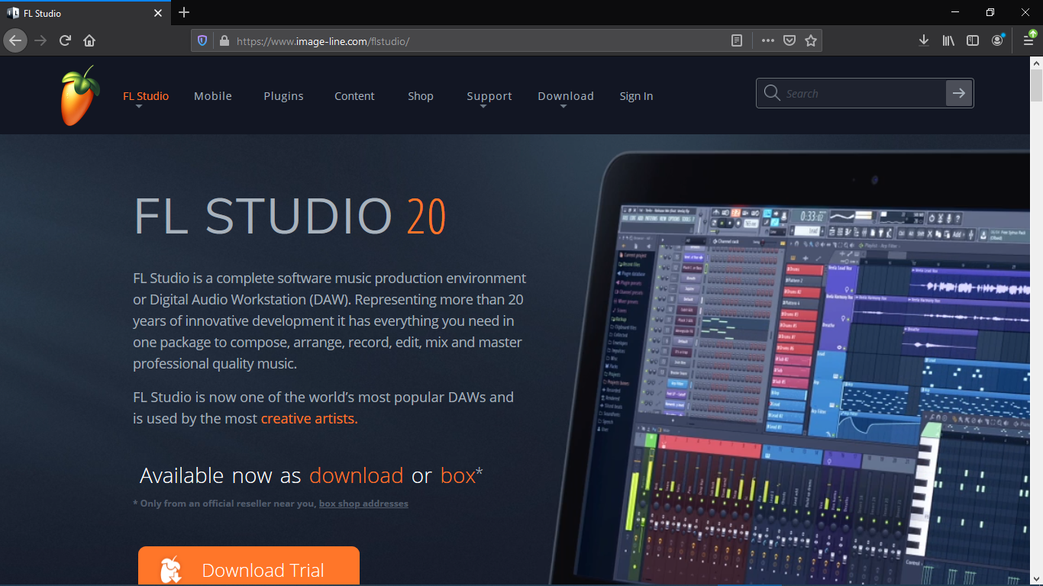

Figure 16

**Content wise:**

Based on the above guidelines this website pretty-much will have 5/5 stars. It has a stable website that works on almost all web browsers and everything is concise and to the point. All external links are opened in a new tab. The information is current and up to date**.**

**Authorship:**

The owner of this website is a very respectable company known as the Image Line Company or the IL Company 

**Technical:**

Every link works fine and the website is stable. They also have a really good support team that will help whenever one encounters issues, be it while downloading the software or operating on it.

Overall this is a very appealing website that has everything in a very organised way.

**B. Envato Market:**

This is an online platform where everybody, and I mean everybody can sell their digital products. You can sell a lot of your work, all sellers are known as Authors in the Envato world and each author can have a different set of skills, be it a Software Engineer, A production Engineer, a Photographer, a Web Designer/Developer and many more.

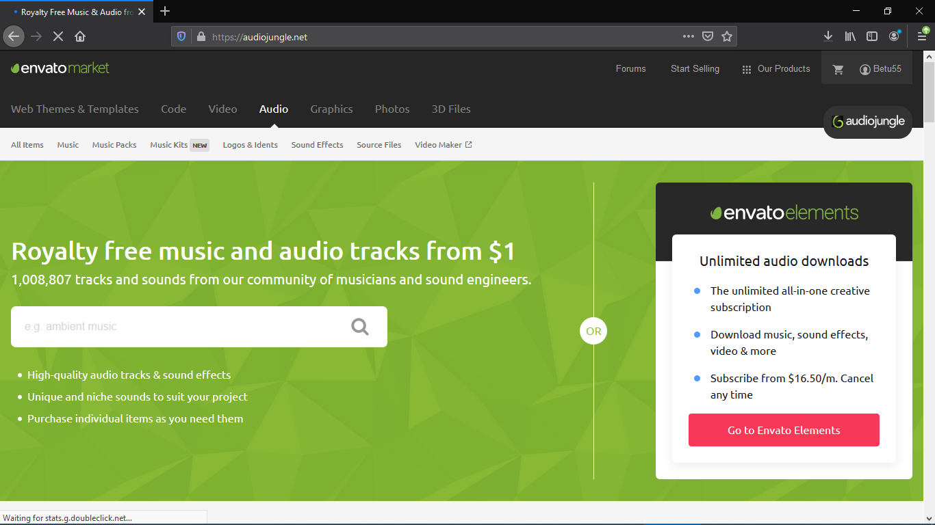

Figure 17

The website above is the Envato Market’s official website, which has a pretty slick user interface.

**Authorship:**

Although the Envato team helps in facilitating the selling and buying of products including licencing and copyright related issues and using the website asa medium, all of the software’s and artistic products out there are owned by the creator.

**Technical:**

This website has never had a change in its web URL and it has been stable for as long as I can remember**.**

And all the payments made by customers can reach the hands of the creator/Author in a safe and appropriate way.

**Purpose:**

This is one of the best websites when it comes to being general and of purpose.

Its purpose being to act as an online platform to facilitate the buying and selling of products made by different people out there, It also doesn’t let annoying ads overflow the website. This makes it a very purpose focused website and makes the online workflow even better.

**Content:**

All the contents that are viewed on this website are appropriate and usually have disclaimers and parental advisories to warn users from being exposed to unwanted content. All the products that are made by creators are carefully inspected and then released on the website.

# **Reference:**

**Web URLs:**

* WebArchive, <https://web.archive.org>, Feb 29, 2020
* History, <https://www.history.com/news>, Mar 1, 2020
* Ericdigest, <https://www.ericdigest.org>, Mar 1, 2020
* Liferay Community, <https://liferay.dev/blogs/-/blogs/15-awesome-web-portal-examples>, Mar 2, 2020
* Techworm, <https://www.techworm.net>, Mar 2, 2020
* SimilarWeb, <https://www.similarweb.com>, Mar 2, 2020

JustinReview, <http://justinterview.blogspot.com>, Mar 3, 2020

* WebDesignRankings, <https://www.webdesignrankings.com>, Mar 3, 2020
* eLearningINDUSTRY, <https://elearningindustry.com>, Mar 4, 2020
* All My Faves, <https://blog.allmyfaves.com>, Mar 4, 2020
* Getting Smart, <https://www.gettingsmart.com>, Mar 4, 2020
* Website Setup, <https://websitesetup.org/best-blog-sites/>, Mar 4, 2020
* Aelieve, <https://aelieve.com>, Mar 4, 2020
* Make a Website, <https://makeawebsitehub.com/social-media-sites>, Mar 5, 2020
* WP Mayor, <https://wpmayor.com/>, Mar 5, 2020
* Hubspot, <https://blog.hubspot.com/>, mar 5, 2020